A Water Shutoff Valve has been installed for the six units above our North Parking Lot (13, 14, 23, 24, 29 and 30). The Valve is located in our locked Electric Room, so a board member will need to be contacted whenever water needs to be shut off for these 6 units.

Shutting off the water at this valve means that whenever any of these six units (13, 14, 23, 24 and 29) need the water shut off, we do NOT need to shut off water to the whole building and only need to shut off at this valve and AT LEAST 48 BUSINESS HOURS IN ADVANCE, the Unit Owner needs to:

- Notify Management via email (kelleyk@propadvantage.com) so management can coordinate the access with a Board Member.
- Post written notice on the front door step of each of the 6 units (13, 14, 23, 24 29 & 30) with the Date and Time Frame for the shut off and the contact info for the Unit Owner shutting off the water.
- Schedule shut off during normal business hours, Monday through Friday between 9am to 5pm. Please try to limit the window as much as possible since your shut off is inconveniencing your neighbors.
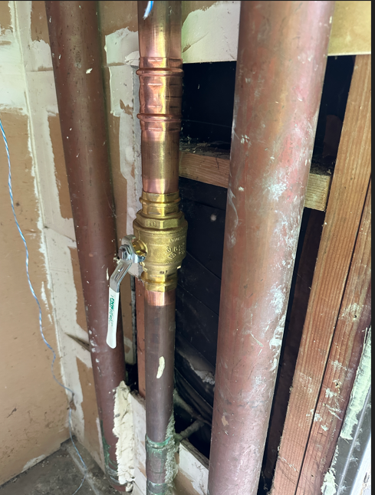

This water shut off valve is just inside the electric room (on the right). The electric room is locked, but all board members have a key, so anytime access is needed, the homeowner will need to contact management or the Board. For any planned plumbing work, we ask the homeowner give 48 hours’ notice to the affected units. For immediate shut off, the owner needs to call or go to the door of each of the 5 units affected to advise the issue and make sure they don’t catch anyone in the shower or rushing to get ready for an appointment.

As of 5/23/25, we have 9 unit out of 30 units, that can be shut off independently of shutting off the whole building, because Unit 1 already as a shut off in her unit that controls 1, 5 and 15. However if any of the remaining 21 units need the water shut off, it will shut off water to the whole building.

Our next plan is to have our plumber review the shut off valve already in Unit 1 and provide a quote for installing a similar shut off in: Unit 2 (to shut off 2, 6 and 16), Unit 3 (to shut off 3, 7 and 17) and Unit 4 (to shut off 4, 8 and 18). Hopefully we can afford to do that this year. Then our final effort will be to create shut offs next year in the garages for the main section of the building.

For questions, please contact our property manager or Linda Shafer

