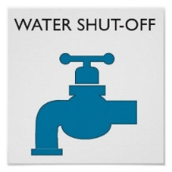
Tu Casa HOA Rules and Regulations
Related to Water Shut off
1.2 Shutting off the Water. Shutting off the water main for regular maintenance, repairs, or remodeling may only be scheduled on weekdays. The owner shall notify Management via email (kelleyk@propadvantage.com) and post written notice 48 hours in advance at the 10 designated locations. Notice is required to allow time to contact our landscape and cleaning people so the water shutoff does not disrupt their ability to service our HOA and incur additional costs. NOTE: Least impactful is to schedule between 9-5 on Wed or Friday
The 10 designated locations are:
- The Main Lobby Bulletin Board
- The First-Floor Door to the 3 Secondary Stairwells
- The Unit Doors of Units 1-4
- Inside Both Elevators
Notice must include:
The day, date and time water will be shut off
Your Contact Info (Name, Unit # and Phone Number)
At time of water shut off:
The Unit Owner is responsible for making sure a notice is posted on the shutoff valve itself stating water is shut off for maintenance and providing their Name, Unit # and phone #
Unit Owner also needs to make sure the valve is turned on and off very slowly (over 5 minutes) to limit pipes shaking
Note: Units 13, 14, 23, 24, 29, 30, 1, 5 and 15 have a separate water shut off valve (and do NOT need to shut off water to the whole building). Please see separate document for these 9 units or contact Management

