* **We have a new LOST & FOUND BASKET:**

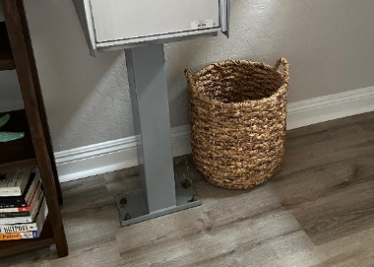As personal items are found around the pool area, club house, etc (shoes, shirts, keys, cups, etc) please look for them in the Lost & Found Basket in the lobby

**Please note:** We will clean out the basket the first of each month, so if you are missing any personal items, please check the basket before the end of each month.

* **REYCLING – the City of Carlsbad requires multi-family complexes implement a recycling program:**  By now, you should have received an email from our Property Manager with the official notification to our HOA regarding recycling compliance and guidelines. It is a lot to digest, so your Board is going to work to deliver reminders to help us all get better at this.

**RECYCLING REMINDER #1:**

**Do NOT put PLASTIC, STYROFOAM or PLASTIC BAGS in RECYCLE BIN.**

If you collect recyclable bottles inside a plastic bag, dump the bottles in the recycle bin and the plastic bag in the landfill waste bin.

If you are dumping boxes, break them down and put only the box in the recycle bin. Put any Styrofoam or plastic packaging materials in the landfill waste bin.

**For additional information, you can contact:**

Call Carlsbad Sustainable Materials Mgmt Div @ 442-339-2646

Call Republic Services @ 760-332-6464

E-mail [Carlsbadca.govcarlsbadservice@RepublicServices.com](mailto:Carlsbadca.govcarlsbadservice@RepublicServices.com)

Visit [Reduce, Reuse, Recycle | Carlsbad, CA (carlsbadca.gov)](https://www.carlsbadca.gov/departments/environmental-sustainability/reduce-reuse-recycle)

**Enjoy our slice of paradise while being considerate of your neighbors, the property and our earth!**

Board of Directors

Sept 2022 – Aug 2023

* Keyur Nagrik

President

* Kevin McAllister

Vice President

* Linda Shafer

Treasurer

* Kathleen Rohan

Secretary

* Paul Tecker

Member at Large

Website: **tucasahoa.org**

ASSOCIATION MANAGEMENT

Property Advantage

5142 Avenida Encinas

Carlsbad, CA 92008

www.propadvantage.com

Cori Shipp , PCAMM

Community Association Manager

[Phone: 760-585-1761](mailto:cshipp@propadvantage.com)

HOA Assessments

Due the 1st of each month

Delinquent on the 15th

Annual Meeting

September 20, 2023

At 6:30pm

**Tu Casa HOA**

Board of Directors

Sept 2019 – Aug 2020

* Angel Brown

President

* Kirk Cowles

Vice President

* Gerrie Boone

Treasurer

* Linda Shafer

Secretary

* Lynda Savage

Director at Large

ASSOCIATION MANAGEMENT

HOA NEXUS

2775 Congress St, Ste 2F

San Diego, CA 92110

www.hoanexus .com

Phone: 619-359-3457

email [support@hoanexus.com](mailto:support@hoanexus.com)

Community Association Manager

* Ryan Galasso

**Tu Casa HOA**

**75% of our waste is recyclable!**